CMPSC 221
Team 30
Kevin Fanning, Jeff Dreyer, John Anderson

The components in the system include a static MediaStore class, an abstract Media class, and 4 subclasses of Media, Album, Music, AudioBook, and Film.
The MediaStore class contains methods for program to take user requests and return useful data. It contains a linked list of Media that holds all media available in the store. This will eventually be replaced with a database. You can add Media to the store with the addMedia method. list---() returns a linked list of all pieces of Media of a certain type. Login/logout methods take a username and password and log that user in. Eventually the program will search a user database to make sure the password is correct, when databases are implemented. The method purchaseProduct takes a productID and a save location and serves the media file to that location, if the user is logged in and the media exists.
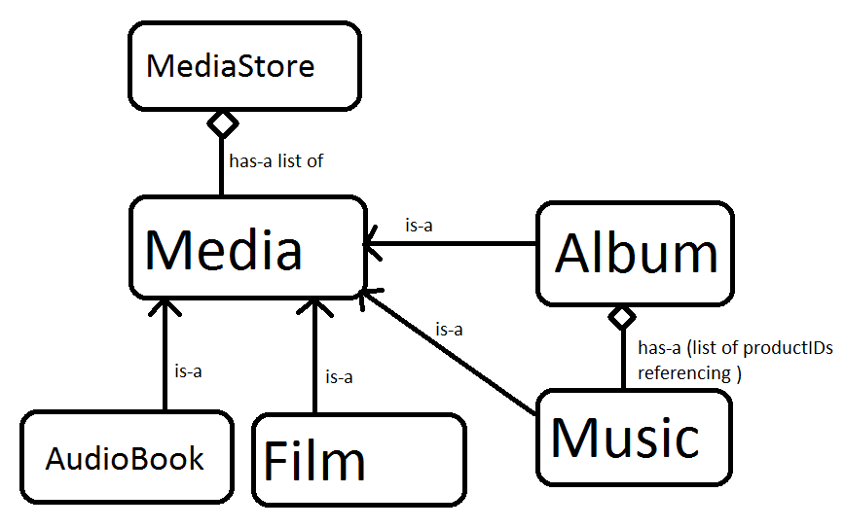
The Media class is an abstract class that serves as the base class for all media objects. It has a static data member called numOfProducts that keeps track of how many products are in the store in order to give correct productID’s out. Every product has a unique ID. The reason we don’t use title is because there may be separate products with the same title. Media has data members for information common to all Media types. These are title, author, rank, cost, productID, and filename. Filename is the location of the media on the server. The initialization constructor, in addition to initializing members, increments numOfProducts and assigns a new productID to the product.
The subclasses AudioBook, Film, and Music just contain extra data specific to that data type. Film and Music have genre, and AudioBook has the number of chapters. The album class just contains a standard vector containing all of the productID’s of the music in that particular album.

Results of StoreTestDriver:
music111
music222
-----------------All--------------------------
music111
music222
book
----------------Books--------------------------
book
The store test driver adds music and an audiobook, and then lists them with both filters. It also uses the purchaseProduct method to save a file over to the /src/ directory. That doesn’t print anything, but is confirmed working.

